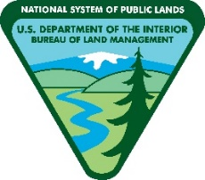
Bureau of Land Management
King Range National Conservation Area
Artist-in-Residence Program
Application Cover Page
Spring 2023
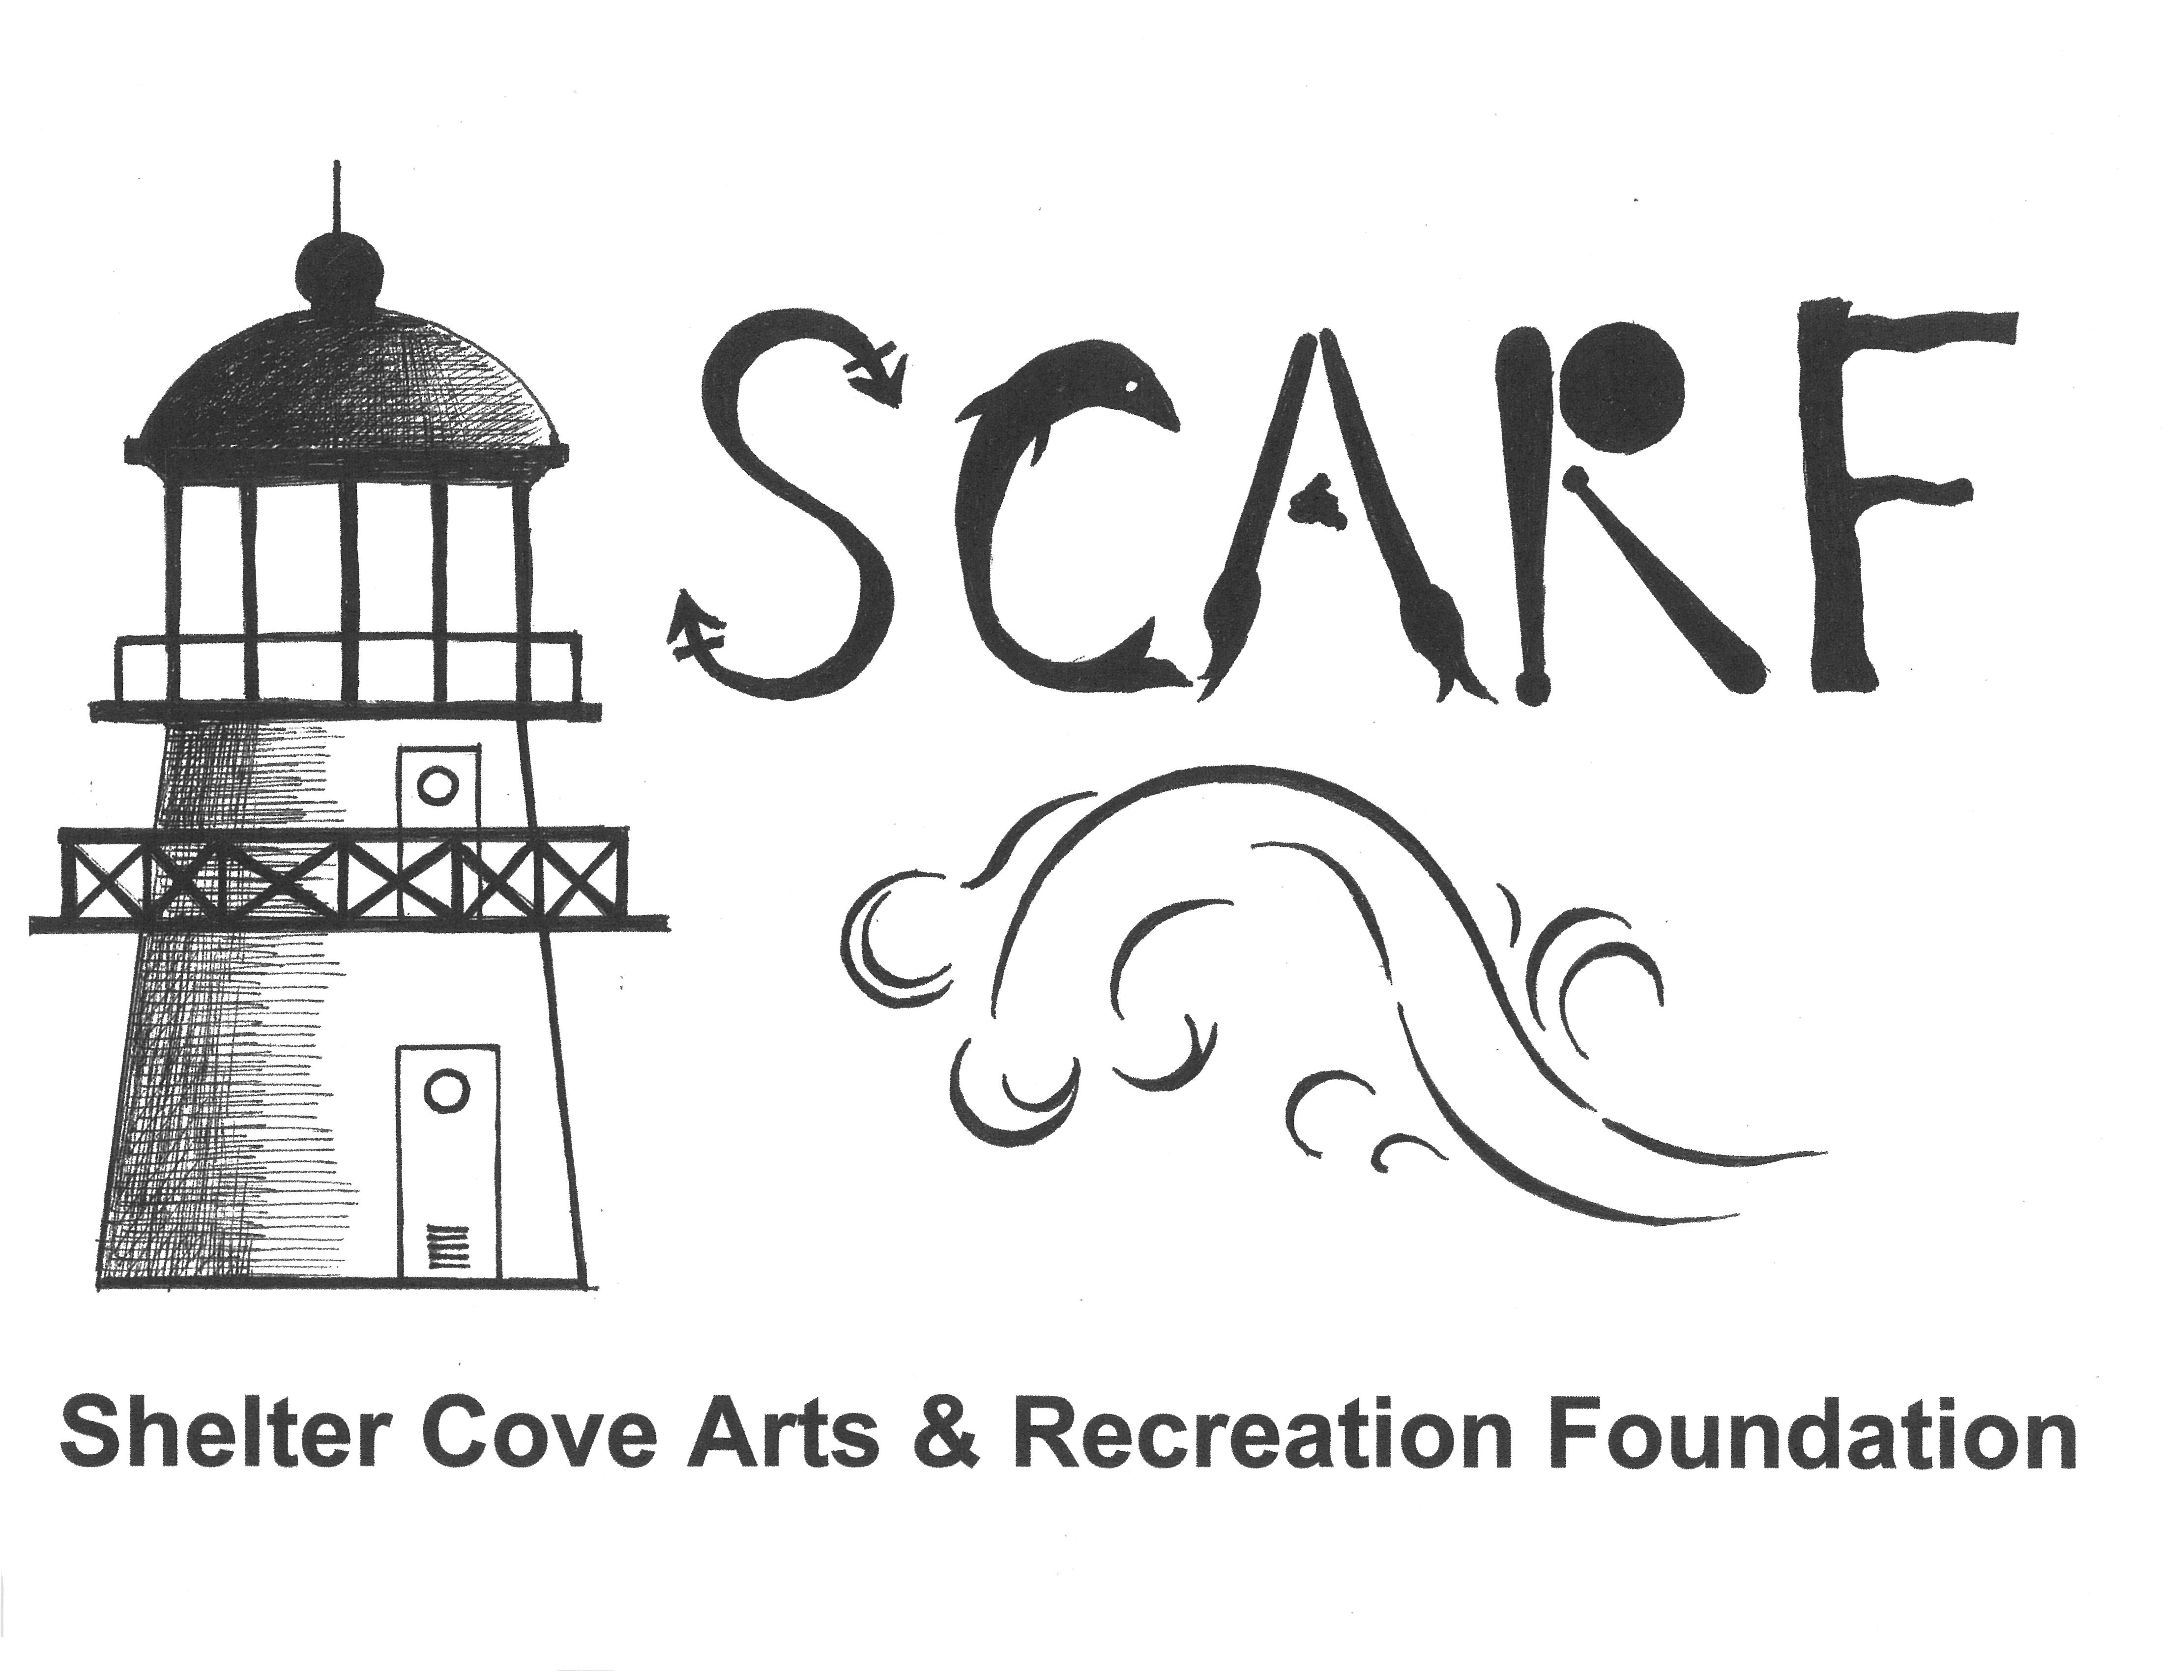

Artist Name:
Mailing Address:
City, State, Zip:
Phone (day, evening, cell):
E-mail:
Website:

I am interested in the 2023 Artist-in-Residence term at King Range National Conservation Area for:
_______ Session #1: 5/15/23 to 6/12/23
Application package due Friday, 4/5/23; 4:00 p.m. via USPS mail or email (smiles@blm.gov
_______ Session #2: 9/25/23 to 10/23/23
Application package due Friday, August 25, via USPS mail or email (smiles@blm.gov)
(Application materials will not be returned)

Comments:

ARTIST APPLICATION CHECKLIST—
Include the following items in your application packet, including this Application Cover Page:
- Sample of Artwork: Submit six visual images of your artwork in hardcopy or on CD, DVD or thumb drive or in readable format via email (.jpeg file format at 300 dpi, not to exceed 1 MB each in file size. Use your last name and image # in file name, i.e. “smith_image 1.jpg”).
- Image List (of sample artwork): Provide a one-page list with title, medium, date, and other relevant information that will assist in the evaluation of your work.
- Resume: Include exhibition record, fellowships & residencies, and other honors. Length not to exceed 2 pages in length, 11-point font, (printed/.pdf/MS Word formats).
Project Proposal: No more than one page, 11-point font (printed/.pdf/MS Word) Your proposal should address:
- Why are you interested in the AIR residency with BLM in the King Range National Conservation Area?
- What art media would you use during your residency? What types of artwork will you create?
- Describe how your personal/professional goals and potential for growth could be met with this residency.
- Elaborate on ideas you have for at least one public presentation/workshop for adults and one workshop for youth (2 total during your residency required).
A full description of the program can be found on the SCARF website: www.sheltercoveartsrecreation.com.
Please email documents to smiles@blm.gov or send hard copies of your application and all supporting documents to:
BLM King Range Project Office, Attn: Sandy Miles, P.O. Drawer 189, Whitethorn, CA 95589.
Please direct any questions to BLM (707) 986-5415.

