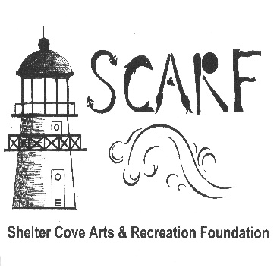  Est. 2012 | 1060 Upper Pacific Rd, Whitethorn CA 95589 707-986-7120 mmitchelltravelor@yahoo.com  https://www.sheltercoveartsrecreation.com/  facebook / Shelter Cove Arts & Recreation Foundation

FOUNDATION MATCHING GRANT FACT SHEET

Overview:

Who Are We?
Shelter Cove Arts and Recreation Foundation was established to improve the quality of life in the Cove by offering art & recreational experiences and activities as well as developing recreation facilities such as hiking trails and ballfields. SCARF has no membership dues, and all activities are free of charge for the local youth. We have a seven-member board of directors and we host public meetings annually. We welcome your input and participation.

As set forth in our 501©3 Articles of Incorporation: "The specific purpose of this corporation (SCARF) is to provide recreational and arts facilities and activities to the citizens, visitors, and the community of Shelter Cove California."

Art: SCARF intends to make the Cove an artist’s destination on par with Eureka, Mendocino, Sausalito, & Benicia. The 2019 launch of the Artist in Residence program was step one. The next largest project being discussed by the Board is reinstating our annual Plein Air outdoor painting event. Our ten-year goal is to develop recurring art events possibly with a permanent venue to hold them.
Sports & Recreation: SCARF currently has commitments & funding to help build a multi-sport court as well as assist in installing a new mountain bike trail.

Throughout the Grant Application process, please convey how your proposed project will assist SCARF in meeting its goals & mission in benefitting the Shelter Cove community.

Please read all stipulations set out in this Fact Sheet prior to completing the application.

Qualifications for Mini-Grants [Mini-grants are usually in the $500 to $1,000 range. Annual total grants not to exceed $2500.

- Matching Funds: Projects are required to have matching funds [50/50] equal to the amount being requested
- Who is Eligible?
  - Local Shelter Cove businesses who want to sponsor a community event or project idea that fits with the SCARF mission
  - Individuals who have grouped together for a common cause.
- Application Process: Mini-Grant applications are accepted twice annually deadlines to be announced.
- Approval Process – complete and submit the application via email to sheltercoveartsrecreation@gmail.com
- Applications are reviewed within 60 days of the application deadline and a decision rendered 30 days hence [within 90 days].

Est. 2012 | 1060 Upper Pacific Rd, Whitethorn CA 95589 707-986-7120  sheltercoveartsrecreation@gmail.com  https://www.sheltercoveartsrecreation.com/  facebook / Shelter Cove Arts & Recreation Foundation

Grant Application

Check one Community Recreation/Sports Community Arts

Name of Organization [or group of individuals] _______________________________________________________

Contact Person[s] ______________________________________________________________________________

Telephone _______________________________________ Email ______________________________________

Project Title/Description & Estimated Cost $ _________________________________________________________
_____________________________________________________________________________________________

Estimated Project timeline to complete______________________________________________________________

Project Location _______________________________________________________________________________

Total Project Cost $_________________________ Grant Amount Requested $_____________________________

Please attach any other supporting documents of assistance in our decision.

THE TWICE ANNUALLY DEADLINES ANNOUNCED ON OUR WEBSITE WILL BE STRICTLY ENFORCED

To the best of my knowledge, the data and information in this grant application is true and correct, and I am authorized to file this grant application on behalf of the organization/group.

___________________________________________ ____/______/_____
Name of Grant Applicant’s Representative Signature Date Title

___________________________________________
E-mail Address

Please submit your application via email to sheltercoveartsrecreation@gmail.com

