THE SHELTER COVE ARTS & RECREATION FOUNDATION (SCARF) PRPOSAL TO THE RESORT IMPROVEMENT DISTRICT #1 FOR A LABYRINTH IN SHELTER COVE

SCARF has over the last few years been approached about creating a labyrinth in Shelter Cove. We would like the RID Board to consider partnering with us to create this community asset.
What is a labyrinth?
The labyrinth is a continuous path, that consists of circles and/or spirals, not a maze or a puzzle. The imagery of the circle and spiral combine into a meandering but purposeful journey. The Labyrinth represents a journey or path to our own center and back again out into the world. Labyrinths have long been used as meditation and prayer tools. The inherent hope built into the labyrinth is that there are no false turns as there are in a maze, but that by putting one foot in front of the other we will arrive at the goal of life. A maze is designed to make you lose your way and a labyrinth is designed to help you find your way. A labyrinth can provide a sense of wholeness, a journey of discovery and provide clarity and understanding in your thought processes. It is a peaceful and quiet experience.

History
Ancient Greek legends tell of King Minos of Crete, who had the inventor Daedalus create a labyrinth beneath his palace in which was housed the Minotaur, a fearsome monster with the head of a bull and body of a man. The Minotaur was said to have been slain by the Greek hero Theseus, who then managed to find his way out of the labyrinth with the aid of a ball of thread that had been given to him by Ariadne, the daughter of Minos. This is the first known labyrinth in historical records.

Fortunately, today’s labyrinths are more benign. Labyrinths are found throughout many cultures and faiths as tools for relaxation and contemplation. They are adjacent to historical churches in Europe and can be found locally outside of Garberville, in Eureka and throughout the world. Today’s labyrinths are for meditative purposes and allows individuals to experience stress reduction, renewal, and inspiration. The labyrinth we are proposing is similar to one in Sedona, Arizona. While walking through the labyrinth you walk on the left side and concentrate on problems, stress, etc. When you reach the center pole and start walking on the right side you concentrate on solutions to the problems in your life.

SCARF PROPOSAL
SCARF would like to develop a labyrinth on RID property adjacent to the Nature Trail on the cleared lot on Upper Pacific Drive between Sea View and Lower Pacific Drive (Lot # 111-181-006). The labyrinth would be approximately 51 feet in diameter with an entrance close to Upper Pacific and an exit 180 degrees from the entrance. SCARF proposes a small addition to the current trail that would lead from the exit of the labyrinth to the nearest point of the current trail. It is believed that no trees would need to be removed but some of the low shrubs.

The Labyrinth would not need to be a permanent structure. There would be an entry and exit gate and a pole in the center of the labyrinth. There would be a sign explaining the purpose and instructions for using the Labyrinth. We would also place 1 -2 benches around the perimeter of the labyrinth. The construction would consist of mostly crushed rock, (the pathway), and river rock, (for the border). Depending on our fund-raising efforts it is possible we would use pavers inside the labyrinth in lieu of crushed rock. The lot would allow for a few parking spaces adjacent to Upper Pacific Drive in addition to the space required for the Labyrinth. A labyrinth is a quiet and peaceful endeavor and would not create any noise pollution for neighbors.

This design would not require any water or access to water. The center pole at this time is contemplated to be a carved redwood log eight to 10 feet in height. It is anticipated that some flowering plants such as daffodils, calla lilies, Douglas iris, and other native plants that support themselves without external water would be located outside the labyrinth.

SCARF would provide the materials, labor, and energy to create this asset to the community. In addition, SCARF would take responsibility for maintaining the site after completion of the labyrinth. We are asking RID to provide the land. If at a future date, the RID Board decides to use this land for another purpose it is understood that the Board reserves the right to do that. SCARF believes that this land was at one time dedicated to recreation, specifically for the back nine of the golf course. We believe that the labyrinth would fall under the same category of land use.

We also believe this asset would not only be used by our local residents but also would increase tourism in Shelter Cove as there are individuals that actively seek out labyrinths. Creating this project would reflect positively on both SCARF and the RID Board and enhance recreation and diversity in recreation for our community.
Implementation
We would hope to start this project by the Summer of 2023 with completion by the end of the year.
Please find attached a diagram of the flow of traffic for the labyrinth. Please note that the borders are 12” wide and the pathways (brown) are 24” inches wide.
Following the design, you will find a variety of pictures of different labyrinths for your consideration.

Exit

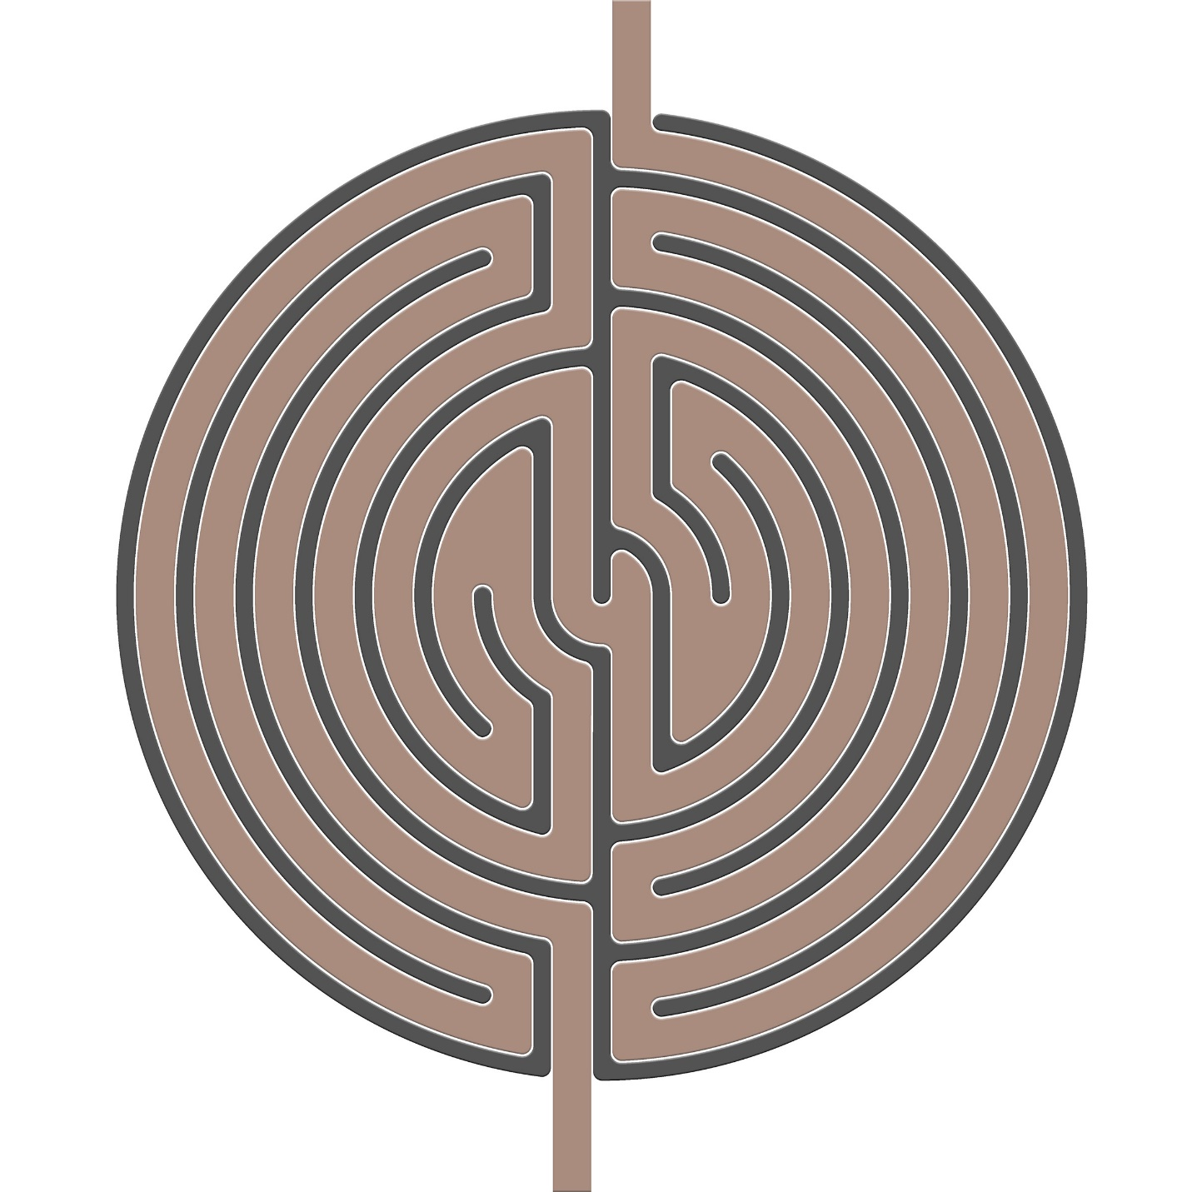
Entrance

A variety of pictures of Labyrinths

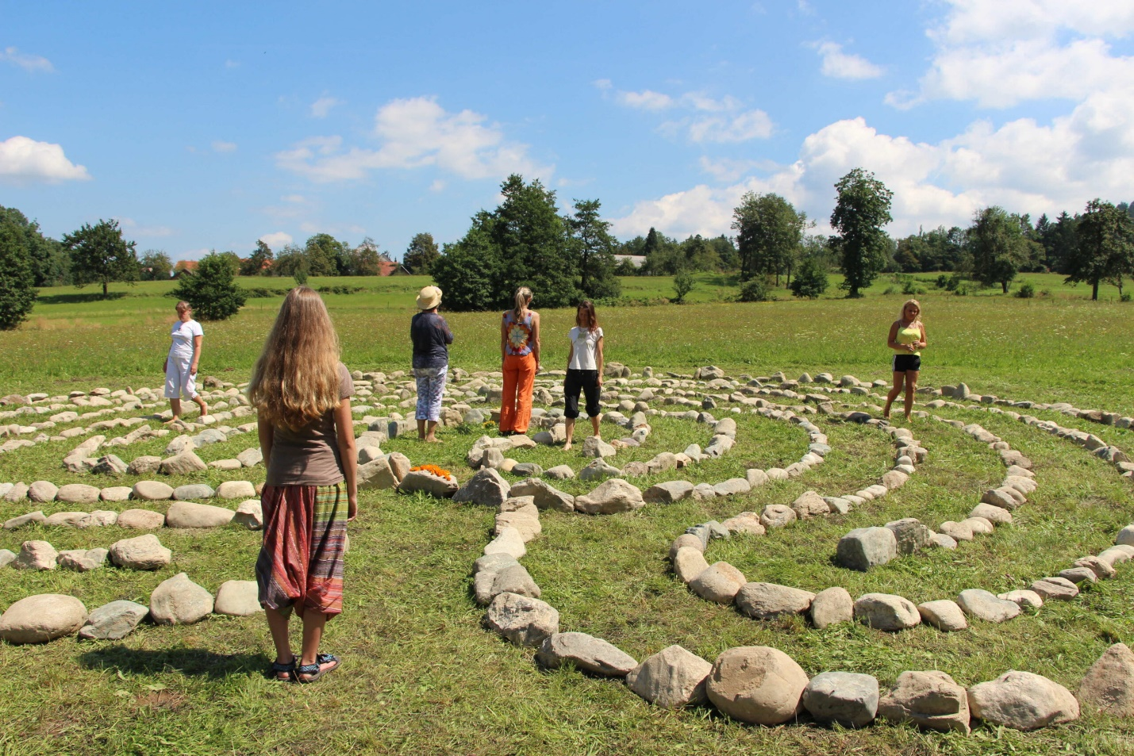

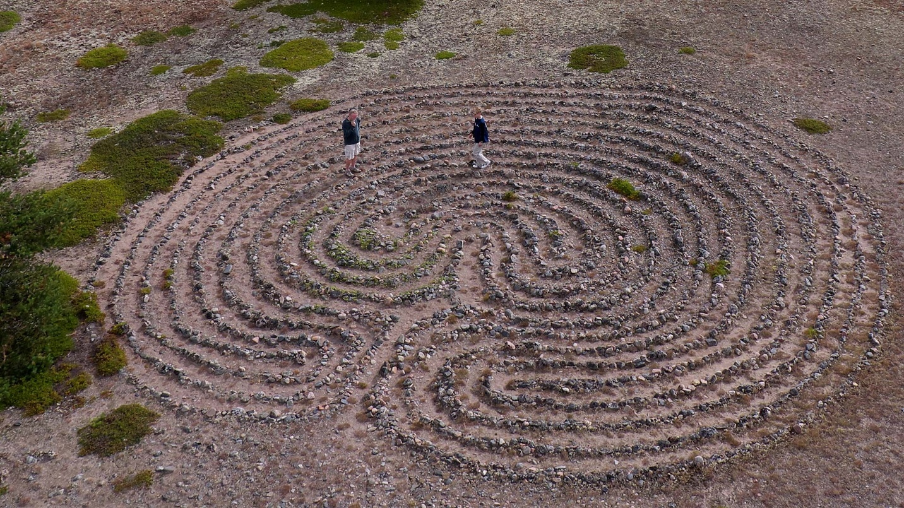

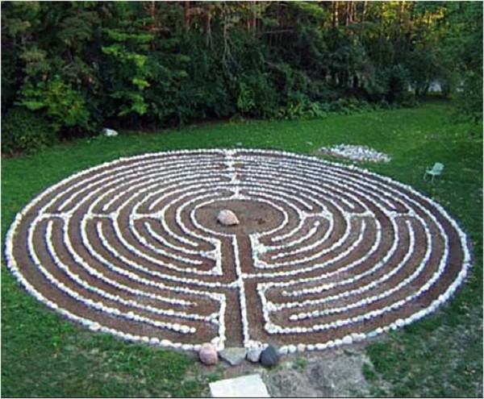

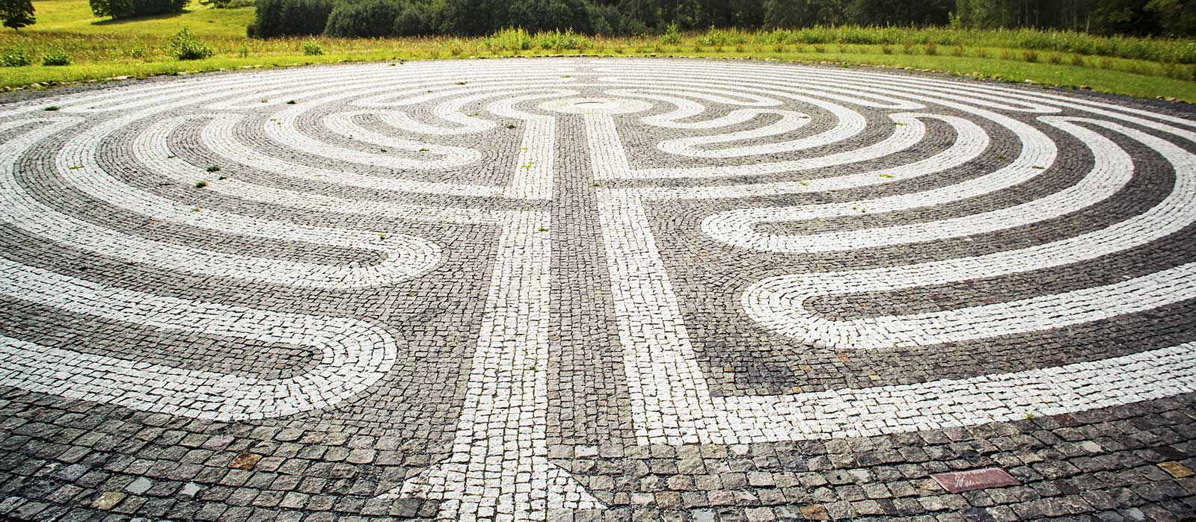
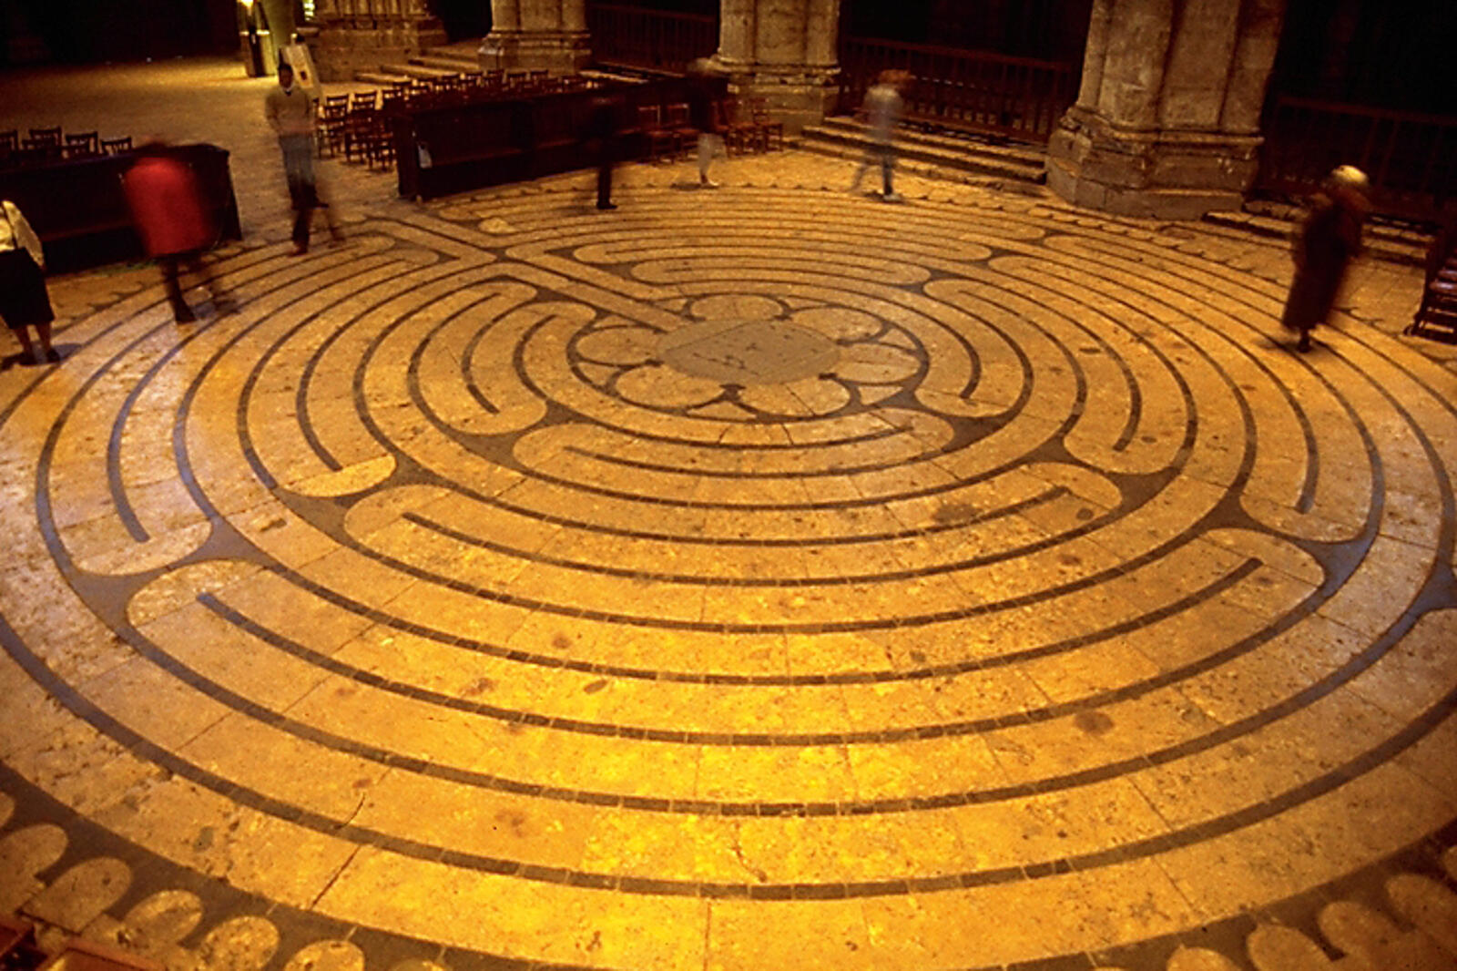
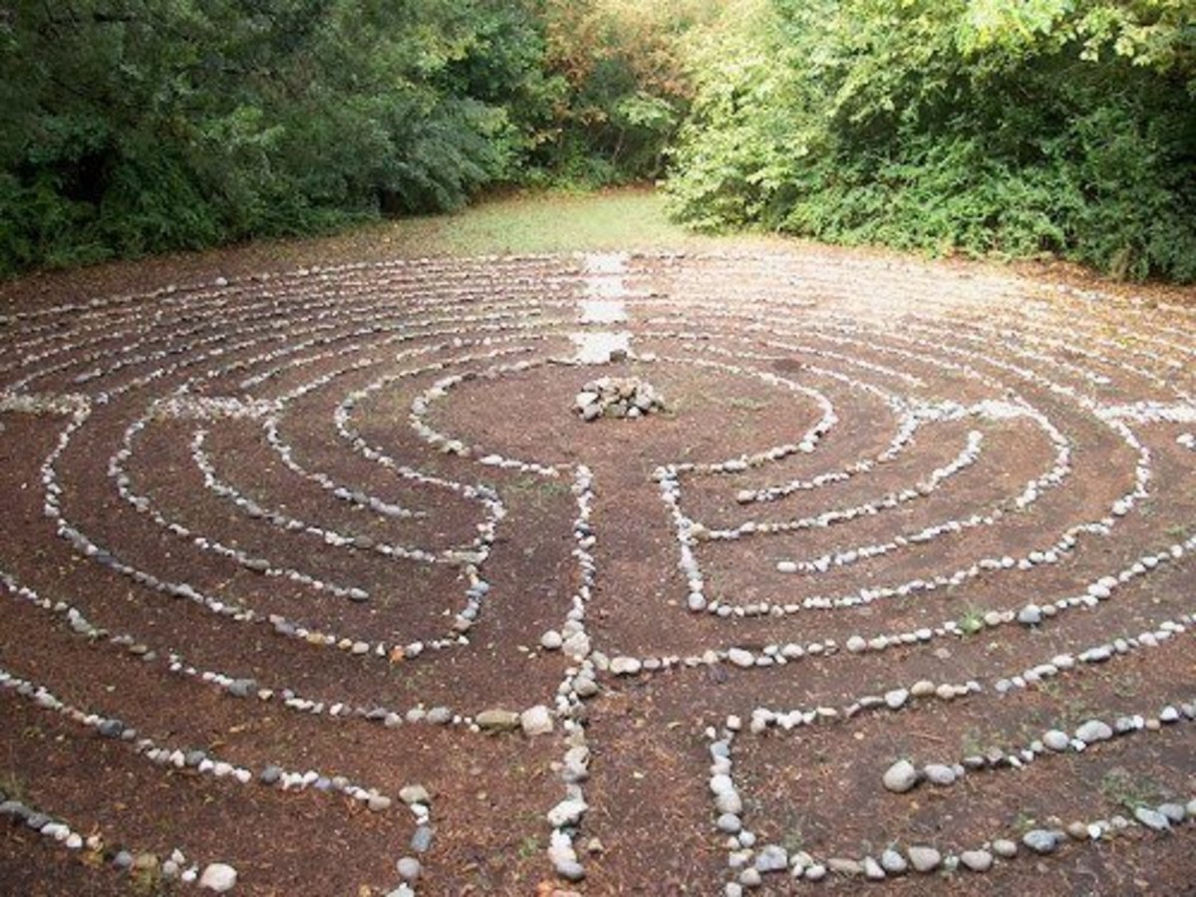
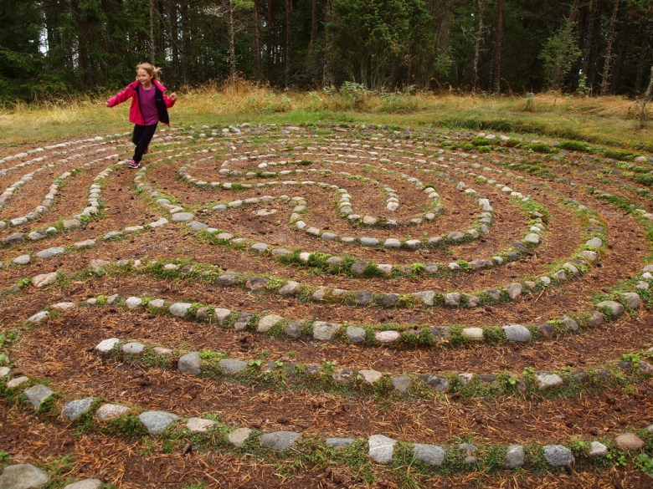

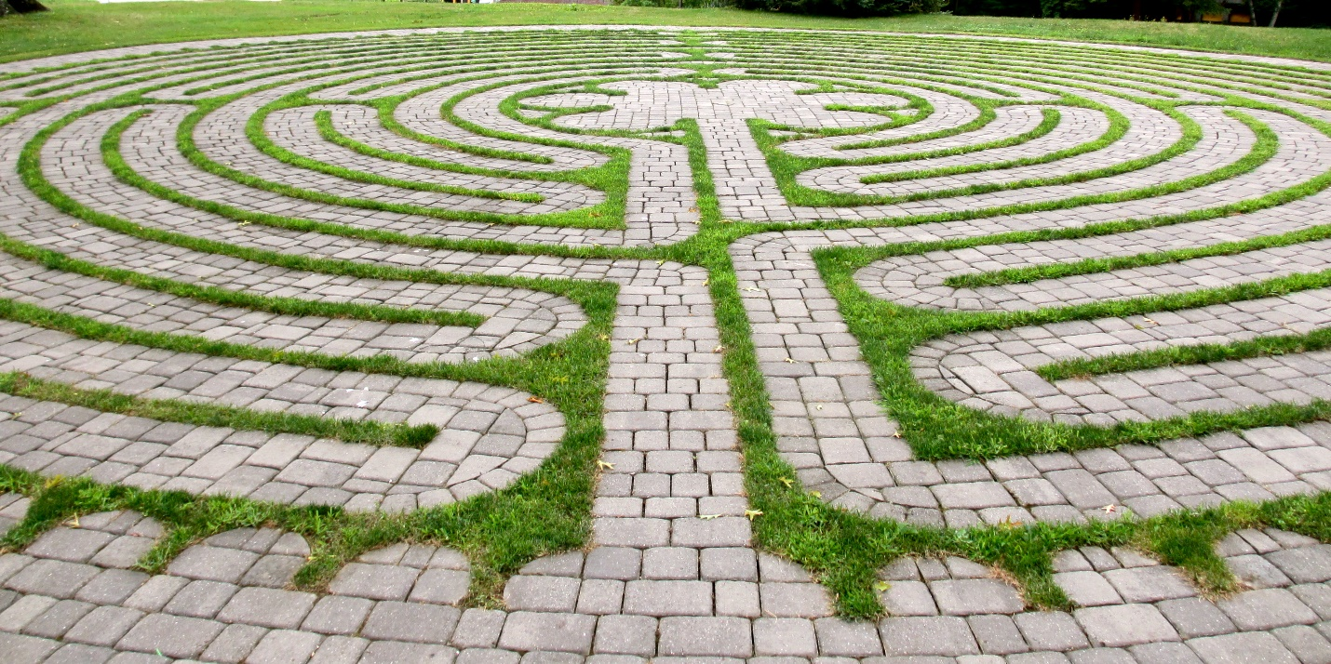

Pictures of Sedona Labyrinth

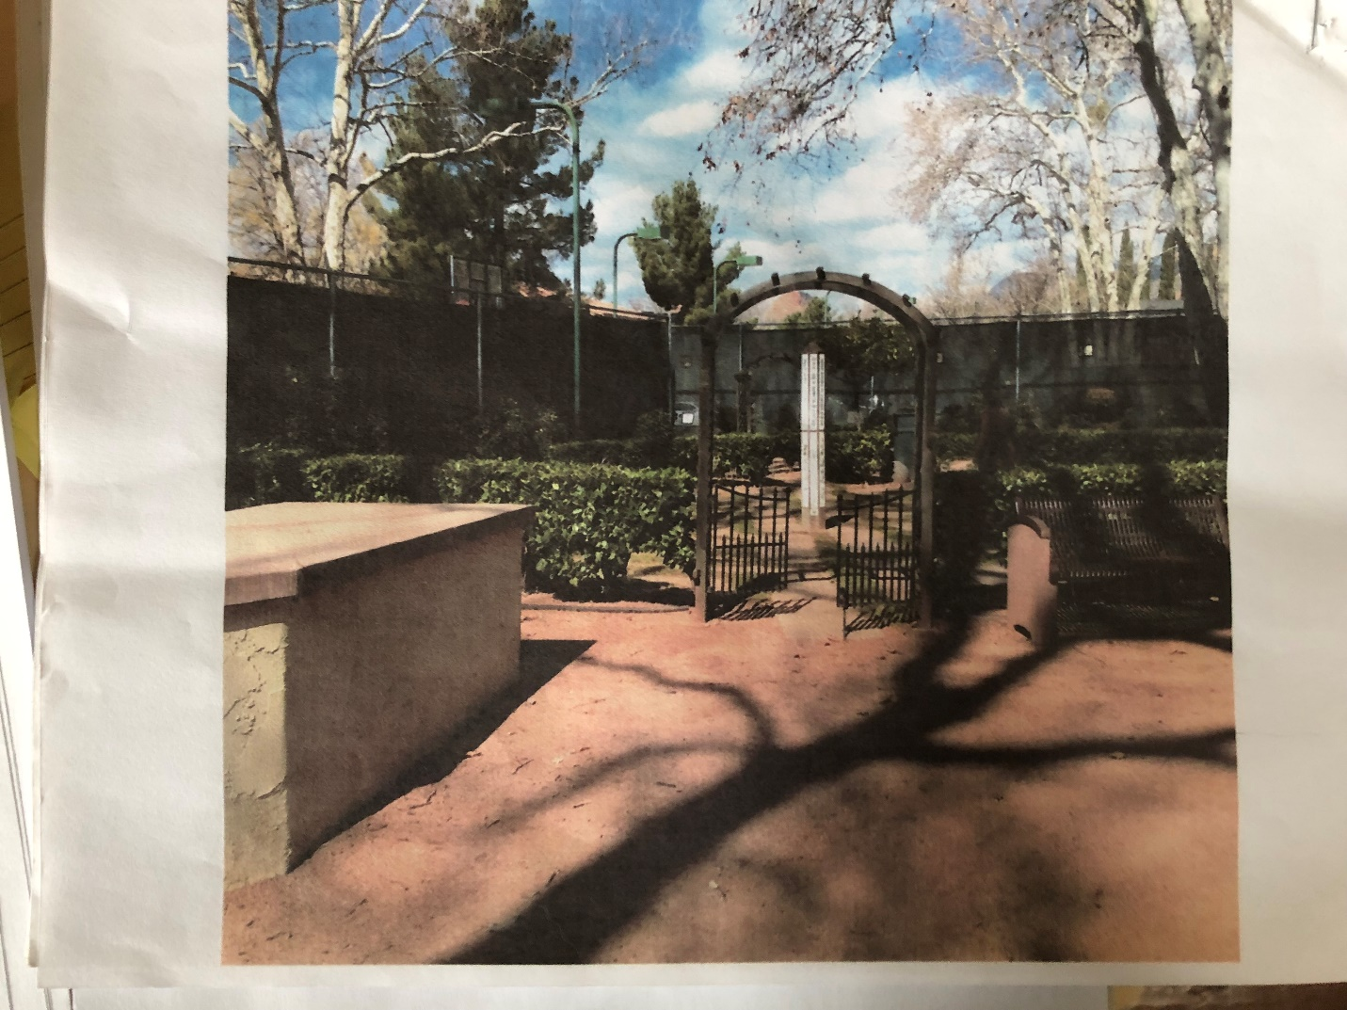

Picture shows entrance gate
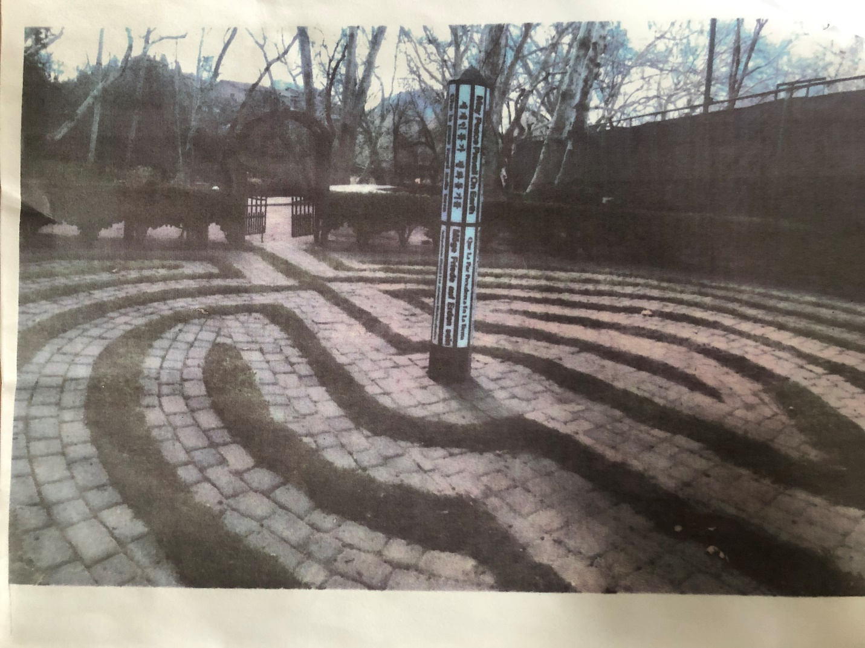

Picture show pathways and center pole

Thank you for your consideration!

